ERASMUS + STEP BY STEP

GENERAL INFORMATION
1.You can go to study within the Erasmus+ programme for one semester or one full academic year.
2. You can go to study at the first, second and third cycle.

BEFORE MOBILITY
1. First, select the university where you intend to study from our list - https://powislanska.edu.pl/umiedzynarodowienie/uczelnie-partnerskie/.
Check if the university offers subjects that correspond with your field of study or discuss it with our Erasmus + employee. If you have doubts about your choice, you can always write to us an email and we will help you – erasmus@powislanska.edu.pl
2. Find out how to organize studies abroad, so you don’t lose anything at the sending institution (PSW) - go to the website of the receiving institution you want to go to, and collect information on the conditions of studying, subjects, academic calendar and possible accommodation.
3. You will be informed about your enrolment to the Erasmus + program by e-mail from the International Office of PSW when your official nomination to the receiving institution has been sent. After a successful nomination, you will receive an email from the receiving institution which you need to read in detail and follow.
Do not exceed any deadlines for sending the necessary documents!
4. Make sure that International Office sends information about your eligibility for the Erasmus+ programme to the Dean's office
5. Download the list of subjects from the receiving institution, and the list of subjects from the sending university planned for the semester of your departure. You can get it from the dean's office. Send both of these lists to the dean responsible for your major since you need to consult him on what subjects you should study abroad. If you need help with this, you can also write to us at erasmus@powislanska.edu.pl
6. After the dean's approval and the selection of appropriate subjects, with the help of our Erasmus + office, you must create your ONLINE LEARNING AGREEMENT (OLA), which is an agreement containing your date of departure for your Erasmus+ stay, and subjects that you will be completing at a receiving institution. Make sure to select the subjects that most closely correspond to the subjects from your sending university (SAN).
* If there are any subjects at the sending university that could not find an equivalent at the receiving institution abroad, but they must be passed - contact the lecturers from these subjects and discuss the conditions for passing them.
7. Before you create an OLA, please set up a Google account first since it is needed.
*If you don’t want to set up a Google account, please contact us since the procedure of uploading OLA is different then.
To create an OLA, go to the website - https://www.learning-agreement.eu/
Click on "Login to Access Your Learning Agreement", log in with your Google Account that was set up before, and follow the instructions. Fill in all required fields and be sure to include the correct dates and contact addresses.
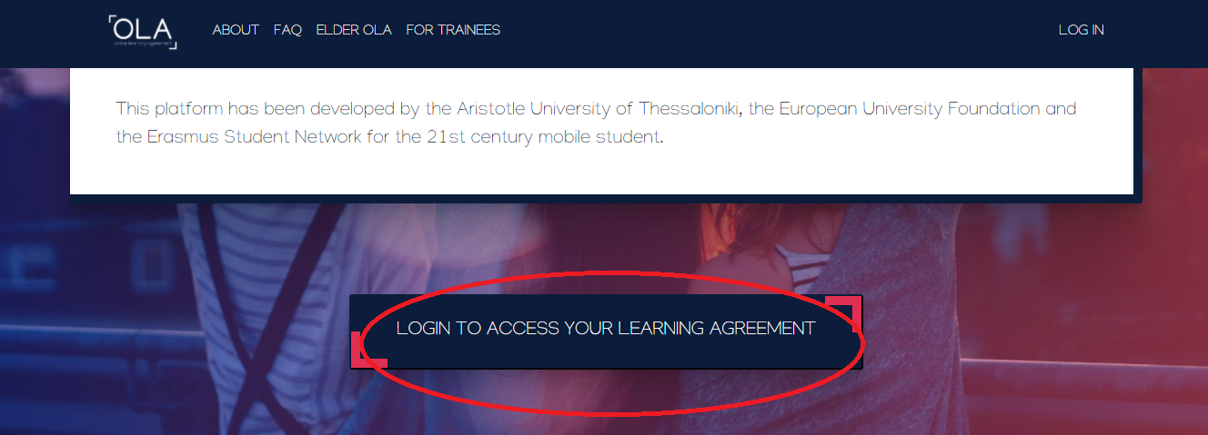
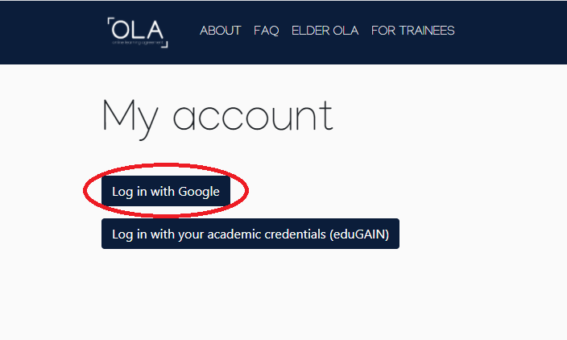

8. In step two, enter the data of the Erasmus + program coordinator at your sending university, and the data of the dean of your field of study on the right.
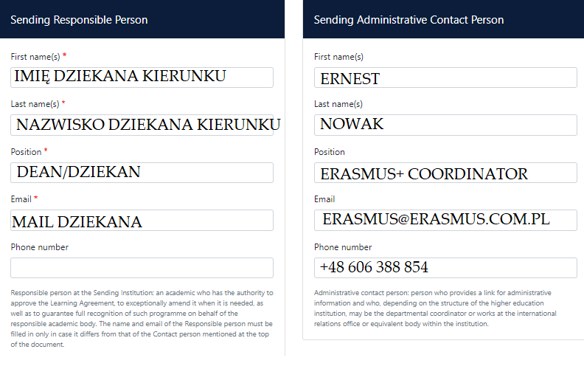
Remember to choose the country and the name of your sending institution from the drop-down list
9. In step three, enter the data of the Erasmus + program coordinator at the receiving institution. If you don’t know what data you should put, please write a mail to the Erasmus+ office from your sending institution
10. In step four you have to put the names and codes of subjects with their ECTS points:
- in table A put subjects from the receiving institution that were chosen by you and your dean (they need to carry between 15-30 ECTS points)
- in table B put subjects from your sending institution (PSW)
*the remaining subjects from your sending institution that could not find the equivalents with subjects from the receiving institution and couldn’t be put to the table B, have to be passed (consult your lecturers at SAN how you can pass them)
11. After completing all the fields and adding items to OLA, go to the next step and electronically sign your OLA. Remember that subjects you are going to pass during one semester must give a total sum of 30 ECTS points.
12. After you sign the OLA, inform us by e-mail about adding the document to the system and wait for our confirmation and verification of your OLA
13. After receiving confirmation from our International Office that your OLA is correct, send your OLA in pdf to your Vice-Rector (ADVISABLE), or make an appointment and bring the printed OLA. Ask for a signature of the dean in the "Responsible person at the sending institution" on page 2 on the printed page or ask for the scan of it (ADVISABLE)
14. After obtaining the Vice-Rectors's signature on your OLA, please send us a copy / scan of the document, and the second scan / copy to your receiving institution
15. Also remember to send the document "Podanie do Prorektor" by e-mail, which you can find here - https://powislanska.edu.pl/umiedzynarodowienie/student-mobility/
16. Get the d's signature on this document and send us a scan of the signed document to erasmus@powislanska.edu.pl
17. About a month before your departure, you sign a Financial Agreement (2 copies), which you will receive from us by e-mail and which must be completed and signed by you
18. Complete the obligatory language test on the OLS platform (you will receive a request to complete it by e-mail)
19. Make sure that all formalities have been completed (contact: Erasmus office, a dean, a partner university)
20. Find out about the accommodation conditions at the host university. If the university guarantees a dormitory, contact their Erasmus + office. If not, look for accommodation in private apartments using trusted sites. We do not take any responsibility for your choice of accommodation. We advise to take smart decisions and look for only trustable sources.
21. Remember about having a health insurance:
- if you are a student of SAN and you are from Poland, please get yourself an EHIC card (karta EKUZ)
- if you are a student of SAN and you have a different citizenship, please get yourself an EHIC card/NFZ insurance (more information on https://www.nfz.gov.pl/dla-pacjenta/ubezpieczenia-w-nfz/ ) or a commercial insurance
22. Remember about getting yourself a universal student card which can be valid in any country of European Union, e.g. ISEC/Euro 26
23. Remember to open a Euro bill on your bank account since the Erasmus+ scholarship is transferred to your bill in Euro
Groups of countries | Monthly amount of the Erasmus+ scholarship in Euro
Group 1 – Denmark, Great Britain, Finland, Ireland, Iceland, Lichtenstein, Luksemburg, Norway, Sweden, | 520
Group 2 – Austria, Belgium, Cyprus, France, Germany, Greece, Holland, Italy, Malta, Spain, Portugal | 500
Group 3 – Bulgaria, Croatia, Czech Republic, Estonia, Hungary, Latvia, Lithuania, Macedonia, Romania, Serbia, Slovakia, Slovenia, Turkey | 450
Amount of the Erasmus+ scholarship per month for students (SMS mobility)

24. Remember that you get 70% of the Erasmus+ grant before your mobility start, and the remaining rest (30%) of it is transferred to your account after your arrival and providing documents (Transcript of Records, Confirmation of Stay OLS test, etc.)
25. Remember that students who have the right to receive a social scholarship, are going to get additional 200 Euro/month

