- BASICS OF ELECTROCARDIOGRAPHY

A standard ECG is performed with 12 leads:
1) 3 bipolar limbic Einthoven (I , II , III)
2) 3 Goldberger enhanced limbic unipolar (aVR, aVL, aVF)
3) 6 Wilson unipolar precordial (V1, V2, V3, V4, V5, V6)

Re. 1. Eithowen bipolar leads:
- In this lead we place 4 electrodes on the patient's body:
- red electrode - right upper limb(RA)
- yellow electrode - left upper limb (LA)
- green electrode - left lower limb (LF)
- black electrode - right lower limb (so-called reference point; ground)
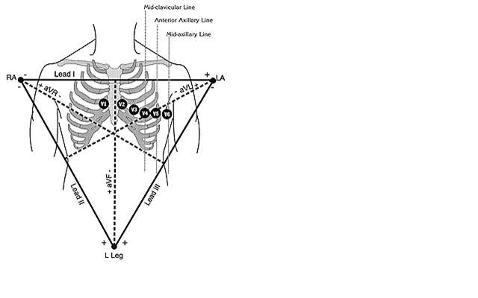

EINTHOVEN TRIANGLE

Lead I - potential difference between the left and right forearm.
Lead II - potential difference between left lower leg and right forearm
Lead III - potential difference between left lower leg and left forearm

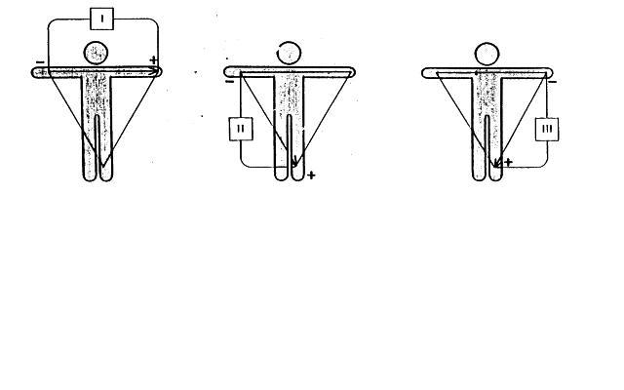

Re. 2. Goldberger enhanced unipolar leads
From the above 3 electrodes we also read the enhanced signals:
- aVR lead - from the "right hand" electrode (RA)
- aVL lead - from the "left hand" electrode (LA)
- aVF lead - from the "left shin" electrode (LF)
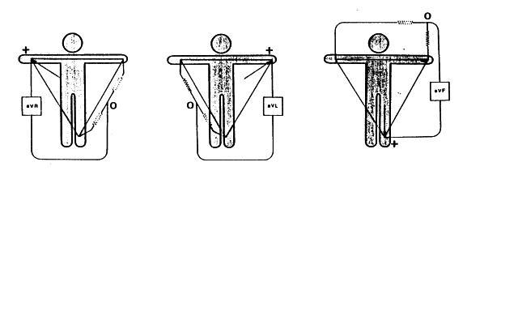
Re. 3. Wilson precordial leads
V1 - electrode in the right fourth intercostal space at the edge of the sternum
V2 - electrode in the left fourth intercostal space at the edge of the sternum
V3 - midway between electrodes V2 and V4
V4 - electrode in the left fifth intercostal space in the left midclavicular line
V5 - electrode in left fifth intercostal space in left frontal axillary line
V6 - electrode in left fifth intercostal space (intercostal space) in left midclavicular line

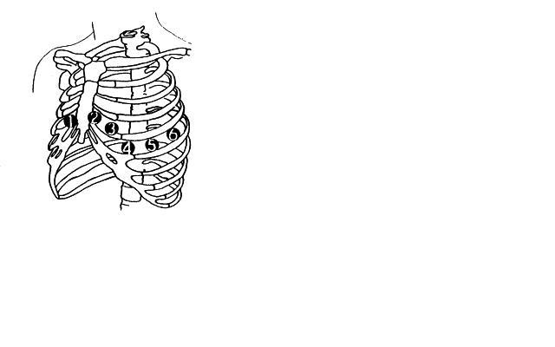

- COMPONENTS OF THE ELECTROCARDIOGRAM

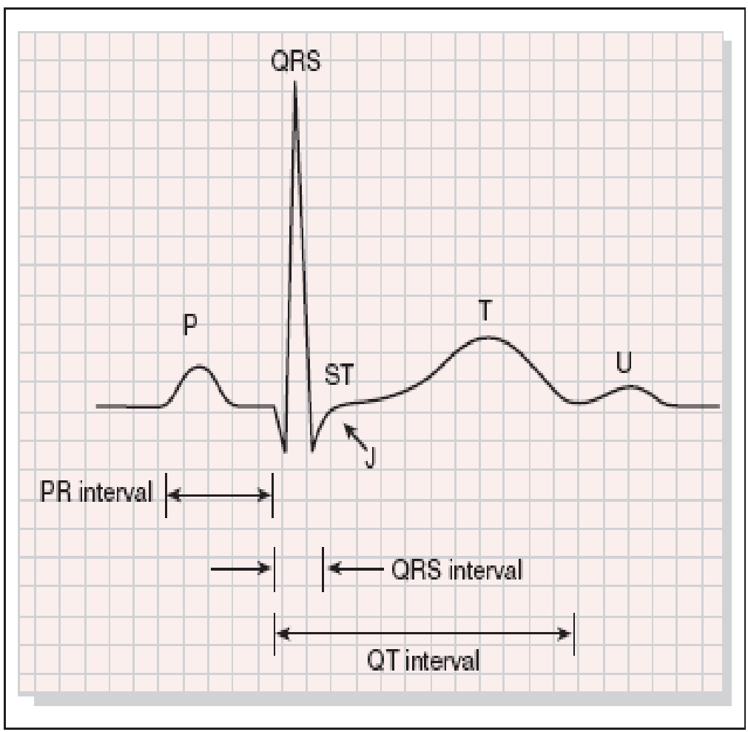

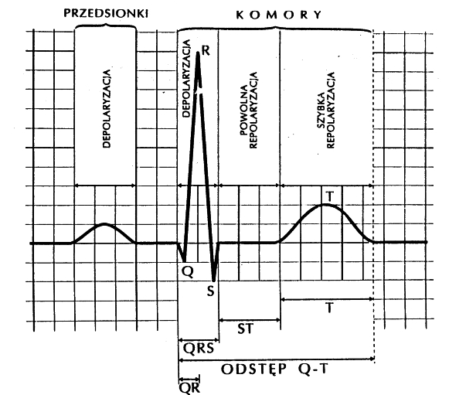
PRZEDSIONKI – atriums
KOMORY – ventricles
DEPOLARYZACJA – depolarisation
POWOLNA DEPOLARYZACJA – slow depolarisation
SZYBKA DEPOLARYZACJA – fast depolarisation
ODSTĘP – gap, interval

Isoelectric line - the horizontal line recorded when no beat is found in the heart. The displacement of all the segments and the amplitude of the refractions are determined in relation to it. The easiest way to determine it is by the TP segment or PQ segment or, when this is not possible, by the line connecting the starting points of adjacent QRS complexes.
P-wave - reflects atrial depolarisation. Gently rounded, directed upwards (positive slope). Normal wave duration is 0.04 to 0.11 sec, amplitude up to 2.5mm (0.25mV) in limb leads and up to 3mm (0.3mV) in precordial leads.
PQ segment - the distance between the P wave and the beginning of the QRS complex. Its duration ranges from 0.04 to 0.10 sec. It expresses the propagation time of depolarisation from the atria to the ventricles. It runs in the isoelectric line
PQ interval - measured from the beginning of the P wave to the beginning of the QRS complex. Its duration is from 0.12 to 0.20 sec.
QRS complex - an expression of ventricular depolarisation. Consists of the Q, R, S. duration is from 0.06 to 0.10 sec. Amplitude in limb leads from 5 to 24 mm and in precordial leads from 8 to 24 mm.
Q-wave - the first negative refraction before the R-wave, often absent. An abnormal refraction is diagnosed when the duration is ≥ 0.04 sec and the amplitude is > ⅟4 of the amplitude of the R-wave in the precordial and limbic bipolar leads.
R-wave - the first positive refraction of the syndrome. R-wave increases in leads V1 to V5 and decreases slightly in V6.

S-wave - the first negative wave after the R wave.
If an S-wave is followed by another R-wave it is referred to as R' and another negative S-wave as S'. When describing the syndrome for emphasis, when the amplitude is large, the capital letters Q,R, S are used and when small, below 5mm, the lower case letters q, r, s . If no R-wave appears then the syndrome is called QS.
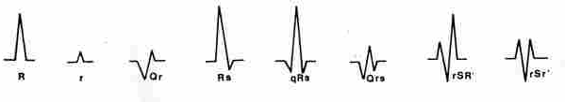
The J junction - is the point at which the QRS complex ends and the ST segment begins. Its dislocation should not exceed 1 mm up or down from the isoelectric line in any lead.
ST segment - the segment measured from the end of the QRS complex to the beginning of the T-wave. an expression of the initial phase of ventricular repolarisation. Duration from 0.02 to 0.12 sec. Runs in the isoelectric line. The depression should not exceed 0.5 mm in any lead and the elevation should not exceed 1 mm in limb leads and 2 mm in leads V1, V2.
T-wave - expression of the final phase of ventricular repolarisation. Duration from 0.12 to 0.16 sec. Amplitude up to 6 mm in limb leads and up to 10 mm in precordial leads.
QT interval - from the beginning of the QRS complex to the end of the T-wave, expresses the duration of the action potential (ventricular depolarisation and repolarisation). It should not exceed .40 sec. The higher the heart rate, the shorter it is.
U-wave - occurs in approximately 25% of ECG recordings. It occurs immediately after the T-wave , preceding the P. positive with an amplitude of up to 3mm. An expression of repolarisation of the Purkinje fibres or stretching of the heart muscle during systole.
The TP segment - from the end of the T-wave to the beginning of the P-wave runs in the isoelectric line. Period of atrial and ventricular diastole.

- NYHA classification of heart failure
I° No limitation of baseline physical capacity. Baseline physical activity does not cause fatigue, dyspnoea, palpitations.
II° Slight limitation of physical capacity.
No symptoms at rest. Basic physical activity causes slight fatigue, dyspnoea, palpitations.
III° Significant limitation of physical capacity.
At rest, still no symptoms. Less than baseline physical activity causes fatigue, dyspnoea, palpitations.
IV° Significant limitation of physical capacity, symptoms are already present at rest.

- CCS (Canadian Cardiovascul Society) classification of the severity of coronary artery disease based on the relationship of coronary pain to exertion):
I - anginal pains only during heavy exertion,
II - anginal pains are minor during normal activities. They appear during, for example, rapid climbing of stairs, up to the second floor and above,
III - considerable coronary pains, e.g. during slow climbing to the first floor
IV - anginal pains during minor exertions and resting pains.

To assess acute heart failure associated with fresh myocardial infarction, the four-stage Killip Kimball classification is used.
Stage | Characteristics | In physical sense
I | no features of heart failure | no features of stasis in the pulmonary circulation, no 3rd heart tone
II | heart failure | stasis in the pulmonary circulation, auscultation of moist rales over the lung fields below the lower angles of the scapulae, 3rd heart tone present
III | pulmonary oedema | stasis in the pulmonary circulation, auscultologically moist rales over the lung fields below, extending above the halfway point of the lungs
IV | cardiogenic shock | hypotonia, peripheral hypoperfusion, often including pulmonary oedema, drop in systolic blood pressure below 90 mm Hg

- Pressure values developed by WHO and the International Society of Hypertension

Systolic pressure Diastolic pressure

- Normal < 140 and < 90
- Mild hypertension 140-180 and/or 90-105

SUBGRAPH:
Borderline hypertension 140-160 and/or 90-95

- Moderate and severe
hypertension ≥ 180 and/or ≥ 105

- Isolated systolic
hypertension ≥ 160 and < 90

SUBGRAPH:
So-called Systolic 140-160 and < 90
borderline hypertension

- Pressure values developed by the American Society of Hypertension

- Systolic pressure Diastolic pressure

- Normal < 130 < 85
- Normal High 130-139 85-89

- Mild hypertension 140-159 90-99
- Moderate 160- 179 100-109
- Severe ≥ 180 ≥ 110

- Myocardial infarction - (Infractus myocardii) - This is necrosis of the heart muscle caused by ischaemia, usually on the background of coronary artery disease with significant narrowing of one coronary artery. Myocardial infarction usually begins with the detachment of an atherosclerotic plaque and the formation of a thrombus occluding the vessel

EVOLUTION OF MYOCARDIAL INFARCTION
 | Full-thickness myocardial infarction:  The necrosis extends through the entire thickness of the heart wall. Q-wave infarction. | Subendocardial (part-wall) infarction:  The necrosis does not involve the entire thickness of the heart wall. It usually involves the layer closest to the endocardium. Non-Q-wave infarction.
I. The first hours of myocardial infarction | There is damage to the heart muscle and ischaemia surrounding the damaged zone. Necrosis is not yet present.  Criteria:  - slightly elevated ST segment  - high symmetrical T-wave  - R-wave normal or slightly reduced | -
II. First day | Area of ischaemia and damage widens necrosis is present in the area of most severe damage.  Criteria:  - markedly elevated ST segment (Pardee wave)  - decreasing R-wave amplitude | The muscle in the subendocardial region is anaemic or damaged. No necrosis is found.  Criteria:  - ST-segment elevation or depression
III. First and second day | The area of necrosis covers almost the entire thickness of the heart wall. Ischaemia and damage are marked at its periphery.  Criteria:  - pathological Q-wave i.e. with duration ≥ o.o4 s and amplitude greater than 255 R-wave height  - incipient T-wave inversion  - ST segment elevation gradually decreasing | Part of the myocardial tissue in the subendocardial region dies, but the area of necrosis does not cover the entire thickness of the heart wall.  Criteria:  - T-wave deep, symmetrical and inverted  - pathological Q-wave absent  - ST segment usually returns to level of isoelectric line  - R-wave visible, may be slightly decreasing
IV. After a few days | The area of necrosis covers the entire thickness of the heart wall.  Criteria:  - pathological Q-wave or QS syndrome (no R-wave)  - inverted, deep and symmetrical T-wave  - ST segment in isoelectric line | -
V. After a few weeks or months | The muscle tissue involved in the infarction is replaced by a connective tissue scar, sometimes protruding as an aneurysm.  Criteria:  - pathological Q-wave or QS syndrome usually present  - T-wave inverted, usually less deep  - R-wave may reappear  - in case of aneurysm formation, persistent ST segment elevation | Small fibrosis present in the subendocardial area previously affected by necrosis, but not extending through the entire thickness of the heart wall.  Criteria:  - T-wave gradually returns to normal, rarely remains negative  - pathological Q-wave absent

LOCATION OF INFARCTION AND CHANGES IN THE ECG
TYPE OF INFARCTION | CAUSE | ECG CHANGES
Infarction of the anterior wall of the heart | Necrosis is caused by occlusion of the proximal branch of the left descending coronary artery | Changes typical of infarction in the leads :  V3 and V4, namely ST-segment elevation, with a high pointed T-wave and a higher R-wave.
Anterolateral infarction | Necrosis caused by stopping the flow through:  - the main trunk of the circumflex branch of the left coronary artery or its branches  - side branch of the left descending coronary artery | Changes typical of myocardial infarction in the leads:  I, aVL, V4, V5 and V6, namely ST-segment elevation.
Antero-septal infarction | Necrosis is caused by occlusion of the descending branch of the left coronary artery. | Changes typical of MI in leads:  V!, V2, V3
Extensive anterior infarction | Necrosis is caused by stoppage of flow through:  - the main trunk of the left coronary artery  or  - both branches | Changes typical of infarction in the leads:  V1 to V6 and I and aVL.
Inferior myocardial infarction | Necrosis is caused by occlusion of the :  - the descending branch of the right coronary artery (80%)  or  - the circumflex branch of the left coronary artery (20%) | Lesions typical of infarction in leadings :  II, III and aVF, namely ST segment elevation.
Infarction of the posterior heart wall | Necrosis is caused by occlusion of:  - the distal segment of the circumflex branch of the left coronary artery  or the posterolateral branch of the descending branch of the right coronary artery | High R-wave in V1 and V2 lead.  ST-segment depression in V1 and V2.  ST-segment elevation in the actual leads from above the posterior heart wall.

Elevation and depression of ST-segment:
- Norm: ST segment at the level of the isoelectric line, represents the early stage of ventricular repolarisation.
- Elevation: an ST-segment > 1 mm in the limb leads and > 2 mm in the precordial leads may indicate a developing myocardial infarction.
Other causes include:
- Pericarditis
- Ventricular aneurysm
- Pulmonary embolism
- Intracranial haemorrhage

- ST-segment depression. Causes:
- Myocardial ischaemia
- Left ventricular hypertrophy
- Intraventricular conduction disturbances
- Contralateral lesions in the leads opposite the area involved in the acute myocardial infarction.

