Hill's classification of cardia insufficiency:
st1 - shallowing of the gastroesophageal angle
st2 - cardia failure depending on the respiratory phase
st3 - cardia failure independent of the respiratory phase
st4 - hiatal hernia

Endoscopic classification of esophageal candidiasis according to Kodsi:
grade 1: several small (<2 mm) whitish slightly raised fungal plaques, without ulceration
grade 2: numerous, raised whitish fungal plaques >2 mm, without ulceration
grade 3: numerous confluent raised whitish coatings, ulcerations may occur
grade 4: as grade 3, with fragile, trauma-prone mucosa and esophageal narrowing

The Boston scale is used to assess the preparation of the large intestine for colonoscopy.
The BBPS scale is based on the assessment of each of three segments of the large intestine:
• left - rectum, sigmoid colon and descending colon,
• middle - hepatic flexure, transverse colon, splenic flexure
• right - cecum, ascending colon.

Table. Degrees of intestinal cleansing according to the Boston scale

 |  | Point endoscopic image Description
0 | 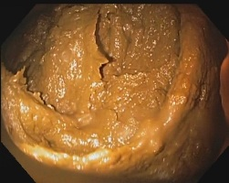 | section of intestine unprepared: intestinal mucosa not visible due to solid stool that cannot be flushed
1 | 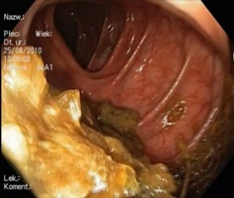 | mucosa only partially visible, the remaining part covered with stool remnants and/or cloudy fluid
2 | 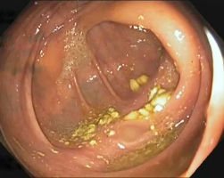 | the mucous membrane is quite visible, a few small remnants of stool, a small amount of cloudy liquid
3 | 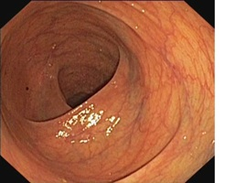 | the mucous membrane of the entire section is clearly visible without any traces of stool or cloudy fluid
A grade ≥2 for each segment means adequate preparation, and a grade lower than this value obliges to repeat the test after better preparation.
The result is given in the form:
BBPS = 4/9 (0+2+2)

